**Project Design Phase-II**

**Data Flow Diagram &User Stories**

|  |  |
| --- | --- |
| Date | 03October 2022 |
| Team ID | PNT2022TMID10940 |
| Project Name | Machine Learning based Vehicle Performance Analyzer |
| Maximum Marks | 4 Marks |

**Data Flow Diagrams:**

A Data Flow Diagram (DFD) is a traditional visual representation of the information flows within a system. A neat and clear DFD can depict the right amount of the system requirement graphically. It shows how data enters and leaves the system, what changes the information, and where data is stored.

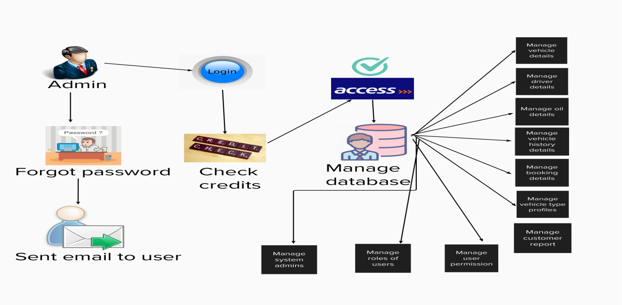

**User Stories**

Use the below template to list all the user stories for the product.

| **User Type** | **Functional Requirement (Epic)** | **User Story Number** | **User Story / Task** | **Acceptance criteria** | **Priority** | **Release** |
| --- | --- | --- | --- | --- | --- | --- |
| Customer | Registration | USN-1 | I may sign up as a customer for the automobile service by providing my email, password, and password confirmation. | I can access my dashboard or account. | High | Sprint-1 |
|  |  | USN-2 | I will get a confirmation email as a client after I sign up for the service. | I can get a confirmation email and confirm it. | High | Sprint-1 |
|  |  | USN-3 | I wish to offer the car model and the fault/problem as a client. |  | High | Sprint-2 |
|  |  |  |  |  |  |  |
|  |  |  |  |  |  |  |
| Admin |  | USN-4 | I'll examine the model's availability as an admin. |  | High | Sprint-1 |
|  |  | USN-5 | When available, go to the service after confirming, then estimate the cost. |  | High | Sprint-1 |
|  |  | USN-6 | If not, email a file to the servicemen with a request so they can help him more quickly. |  | High | Sprint-1 |
|  |  |  |  |  |  |  |
|  |  |  |  |  |  |  |
|  |  |  |  |  |  |  |
|  |  |  |  |  |  |  |